1. **Derived Identifier**: Id or identity derived from an entity.
2. @MapsId annotation helps you to derive/borrow id from some other entity.
   1. To share primary key in mapping.
3. Let’s take a look at the one-to-one mapping from our previous lecture. 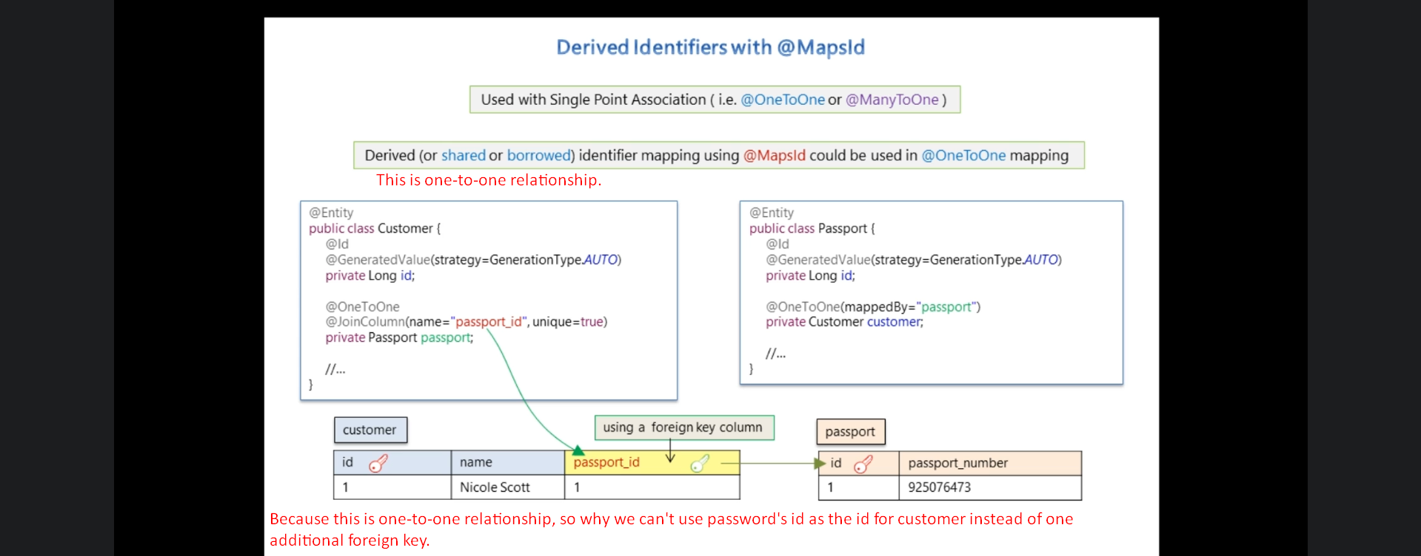
4. 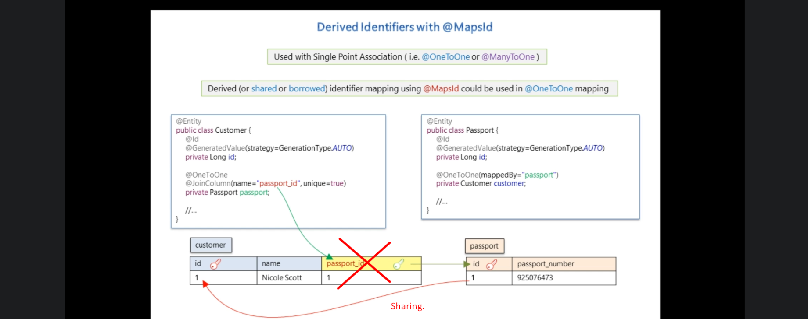
5. 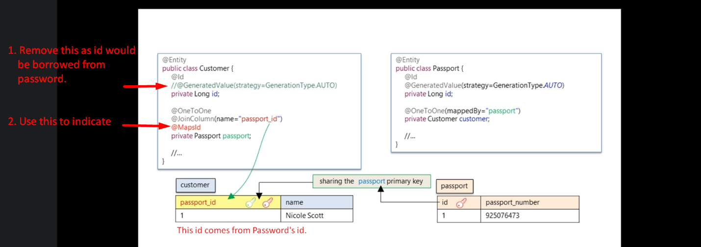
6. 